Modern Business Concept Using Ethereum Blockchain Platform And Google Cloud Platform In Agribusiness

Annur Hangga Prihadi1, Is Mardianto2, Iwan Purwanto3

Faculty of Industrial Technology, Trisakti University, Jakarta, Indonesia

1annur065001800028@std.trisakti.ac.id, 2mardianto@std.trisakti.ac.id, 3iwan.purwanto@std.trisakti.ac.id

Accepted....

Approved....

*Abstract*— Blockchain technology is widely regarded as the choice in technological developments that promote peer-to-peer systems, and decentralized data for organizational data. The supply chain process in the agribusiness sector currently still uses traditional technology where data and documentation of agribusiness products are still recorded and stored on paper or personal databases, and can only be checked by trusted third-party authorities. Blockchain technology has the potential to change the process to be more modern due to transparency in every activity to facilitate tracking and visibility of goods in the supply cause easier auditability of records, for example Carrefour Italia reported that it has implemented a food tracking system with blockchain. The author focuses on building business solutions and blockchain systems on supply chain transparency in the agribusiness sector with the Minimum Viable Product target in the form of Txn supply chain processes, then the author uses the Ethereum network with its Smart Contract products to build a business system and its blockchain. In doing this, the author needs to identify the functions needed to use the Ethereum network to implement business processes and blockchain systems to be run. The product of this research is a prototype blockchain system that generates Txn in supply chain processes for transparency in ongoing supply chain business activities.

Index Terms— Blockchain, Ethereum, Smart Contracts, Supply Chain, Txn

# Introduction

Blockchain technology is widely recognized as an innovative option for developing technologies that facilitate peer-to-peer distributed information systems for corporate data. Blockchain technology facilitates digital currency transactions. In its current development, blockchain can update decentralized currency systems such as Bitcoin, Ethereum smart contracts, the Binance smart chain and other resources that can be managed online.

Blockchain technology allows organizations to exchange data and complete transactions in minutes without the need for intervention or verification by third parties such as banks when processing customer transactions.

Blockchain technology also ensures the security of distributed information exchange. This may have a significant impact on the management of the organization. It can also change the way companies In the supply chain, building relationships and sharing products and information.

Today, agribusiness supply chains are highly structured, global, and interconnected. Information and documentation of agribusiness products on safety, sustainability, procurement and other features. Information is often recorded and stored on paper or in private databases and can only be viewed by trusted third parties. In this situation accessing data becomes expensive, time consuming, and requires action, distortion, and error that threatens the loss of business processes especially in the financial field.

Although the trend of the digital economy continues, agricultural products are still included in one of the fewest digital industries. Blockchain technology can affect this situation in a different way i.e. the food sector can benefit from decentralized digital smart contracts that operate independently and automatically to process transactions and automation between participants in the supply chain.

The purpose of this study is to model the blockchain system that builds Txn in the supply chain process to ensure that ongoing business activities in the supply chain are transparent. Research limitations as follows

* Minimum Viable Product in the form of Txn occurs between supply chains.
* Using the Ethereum network
* Using a smart contract that resides on the Ethereum network

# LITERATURE REVIEW

## Definition of Blockchain

Blockchain technology is a type of ledger used like bitcoin, blockchain creates time series data chains in such a way that the data is immutable. Transaction data is organized into blocks and consensus must be reached to add new blocks to the blockchain node chain. Therefore, to improve the distributed, reliable, and secure nature of blockchain deployment requires a large number of validation tool blocks. Its main components are the blockchain itself, Then smart contract for programmable service level agreements and distributed file storage for hosting transaction data.

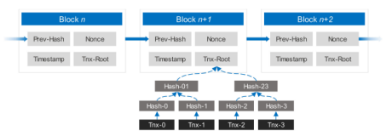

1. Blockchain Structure

## Ethereum

Ethereum is a blockchain-based computing platform with smart contract capabilities that allow users to build decentralized applications running on blockchain technology. In addition to the ledger, Ethereum offers a virtual machine called the Ethereum virtual machine (EVM) that can run scripts written in a high-level programming language (such as Solidity) on Ethereum.

To ensure that the transaction data does not change, Ethereum stores the hash root in the block header. In this case, the tree manages two accounts: an external account (EOA) and a smart contract account. The first type is an account that is controlled by a private key owned by a specific entity and the second type is accounts controlled by bytecode smart contracts. Both accounts are represented by encrypted 20-byte addresses. To prevent denial-of-service (DoS) attacks, Ethereum virtual machines use a gas system. In this system, the completion for each program must be carried out in a special unit known as the gas tax, as defined in the protocol if the supply of gas supplied does not cover the operating costs then the transaction will not be successful.

The price of gas determines the rate of conversion of gas into ether. Gas is a transaction fee that encourages miners to consolidate their transactions on the Ethereum blockchain, so gas is the standard for estimating the operating costs of code on the Ethereum network. Each item has a gas charge based on the expected processing time. The Gas limit is set to prevent an endless loop that misuses the resources of the Ethereum block if the limit is exceeded the transaction will not complete and the associated block will not be mined.

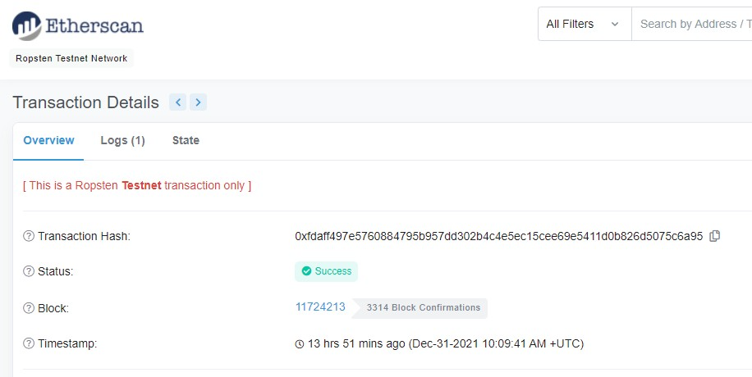

1. Examples of Ethereum Transaction Header Structures

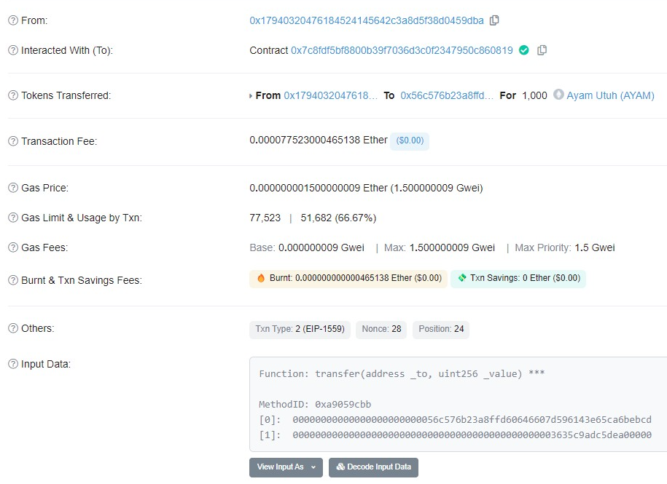

1. Examples of Ethereum Transaction Body Structures

Inside the Ethereum transaction body there is a certain amount of information such as

* From is the Ethereum address that sends the token and that triggers the function of the smart contract.
* Interacted with (to) is the contract address code of a token that has been created using a smart contract.
* Tokens Transferred contains the Ethereum address of the sender of the token that sends the token to another Ethereum address and the data of the token sent.
* Transaction fee is a fee for one token delivery transaction.
* Gas Price is an additional cost of conversion rate from gas to ETH cryptocurrency.
* Gas Limit & Usage by Txn is the maximum and final amount of gas allocated for the transaction. A normal ETH transfer contains 21,000 units of gas, but the tokens generated with smart contracts are higher.
* Gas Fee is the basic cost specified in the block unit. The highest priority fee is the maximum amount that blockchain users are willing to pay and is given to miners when verifying transactions.
* Burnt and Txn Savings Fees are the total amount of ETH burned during the transaction and the total fees saved from the amount the user is willing to pay for the ongoing transaction.
* Other contains Txn Type, Nonce (Testing performed as many as n), and position.
* Input data contains about functions executed by smart contracts that have been written.

## MetaMask

MetaMask is an application and browser extension that simply populer and functions as a cryptocurrency wallet connected to the Ethereum blockchain. MetaMask allows users to interact with the Ethereum ecosystem, which hosts many decentralized applications (Dapps) without having to download the entire blockchain component to their device. Hence being one of the best Ethereum wallet solutions for accessing Decentralized Exchanges, gaming platforms, and many other applications. MetaMask is compatible with the most common browsers such as Chrome, Firefox, Brave, and Microsoft Edge. In addition to storing the base currency Ethereum (ETH), MetaMask also stores tokens built on the standard protocols ERC-20, ERC721, and others.

## Content Management System (CMS)

A CMS is a system that allows users to easily manage, add, and edit content on dynamic browser sites without requiring advanced technical knowledge first.

## QR Code

QR Code, short for Quick Response Code, is a two-dimensional matrix code that can store up to 2,089 digits or 4289 characters, including punctuation marks and special characters. QR codes are very useful for small businesses. Since it can display text to the user and open a URL, a QR code consists of black dots and whitespace arranged in a rectangle and each element has its own meaning, so you can scan the QR code on your device to display the information.

## Flowchart

A flowchart is a diagram that shows workflows and processes, as well as explores and solves problems or it can be a business tool that shows linear workflows. Most people use this diagram to illustrate the project process and decentralization within an organization. Flowcharts are a great and concise way to explain the entire workflow. The purpose of the flowchart is to describe the steps, it can parse and solve problems easily, neatly, cleanly, and you can use symbols. There are actually no exact requirements that must be met in the process of making a flowchart. Because this chart/diagram is designed to analyze business problems.

## Business Process Modeling Notation

BPMN is a business process modeling standard proposed by Business Process Management Initiative. BPMN is designed to be easy to use and understand. It is also able to model complex business processes as a service. BPMN is an easy-to-understand symbol for any business user. From the business analyst who generated the source file of the initiation process to technical developers who are responsible for implementing the technology used to carry out the processes created by BPMN. It can then add options and information to the BPMN parent element to accommodate complex needs without changing the appearance of the underlying diagram.

# Research Methodology

## Ethereum Architecture

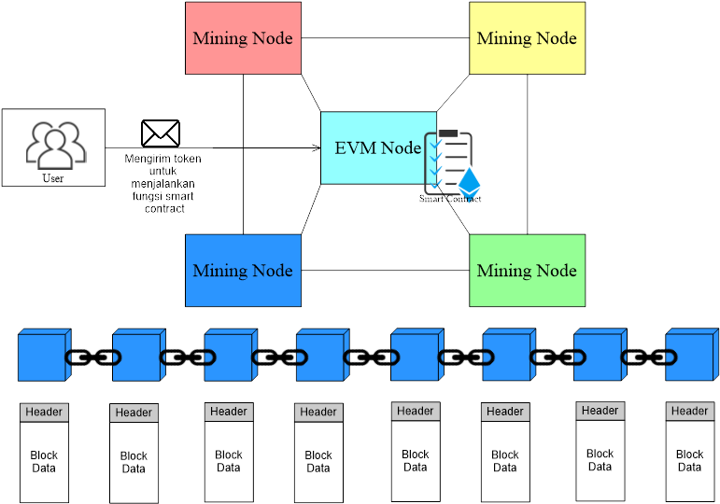

1. Ethereum Architecture

The core idea behind the Ethereum architecture is how users perform smart contract functions built to support the business needs of the blockchain. Writed with smart contracts this architecture shows how interconnected technologies that allow the Ethereum ecosystem to work to create blockchain-based blocks containing transaction data from users. A mining node is a mining machine that monitors transactions carried out on the Ethereum blockchain network, and each block contains information already described in Fig. 3.

## Cloud Architecture

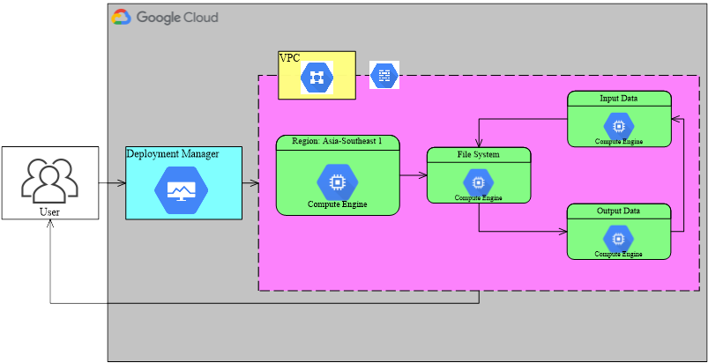

1. Cloud Architecture

In the picture above, it can be seen that the researcher uses the GCP service to make his CMS site online, namely with the Deployment Manager which has been directly integrated with Compute Engine and VPC to facilitate work.

## Creating a Smart Contract

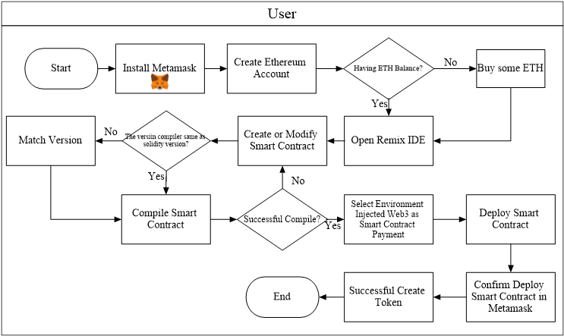

1. Flow to Create a Smart Contract

In the image above the user needs to install the MetaMask application and create an Ethereum account to get the Ethereum address that the user will use. When creating a smart contract deployed to the Ethereum network will cost money. So first check if the user has Ethereum (ETH) by joining the airdrop or buying from a broker. Once you own Ethereum (ETH) you can then open the Remix Ethereum IDE using Ethereum's dedicated development environment at the following link (remix.ethereum.org) users can create and edit smart contracts to use according to business needs. An example of a smart contract from a researcher can be accessed via the following link (https://github.com/hanggaa/PrototypeThesis/blob/main/Token/Skripsi/.workspaces/Skripsi2/hangga.sol) The smart contract created by the researcher works when creating a new token running on the Ethereum network, allowing entities to send tokens between entities as a condition for writing data on the blockchain. After creating or modifying the smart contract the next step is to match it with the compiler. Regardless of whether the Solidity version matches or not, if it does not match, the compilation process will fail. The next step is to compile the smart contract. After a successful compile process the user can run the smart contract on the EVM node or on the Ethereum network. The deployment process is done by selecting Injected Web3 (MetaMask) as the deploy payment method.

## QR Code

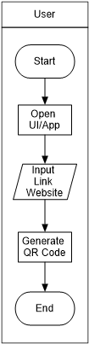

1. Workflow of Printing a QR Code

The user copies the website link stored in the QR Code, pastes the link into the QR Code, then generates a system that converts it into a QR Code and prints it out while simultaneously assigning it as the product label.

## Installing Tokens on MetaMask

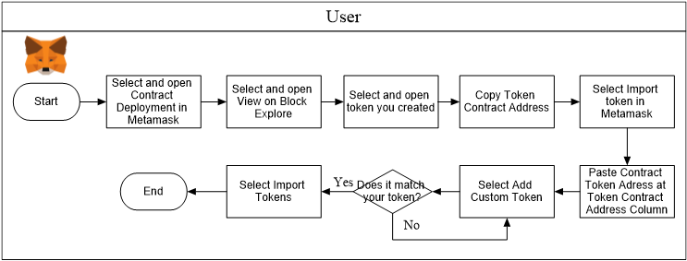

1. Install Smart Contract Tokens on MetaMask

When installing a token on Metamask the user needs to copy the token contract address that can be opened through the token creation transaction details, after the transaction details are open then copy the token contract address and select "Add Custom Token" in MetaMask. After the custom token opens paste the token address that was copied earlier.

## Supply Chain Business Processes Using Blockchain

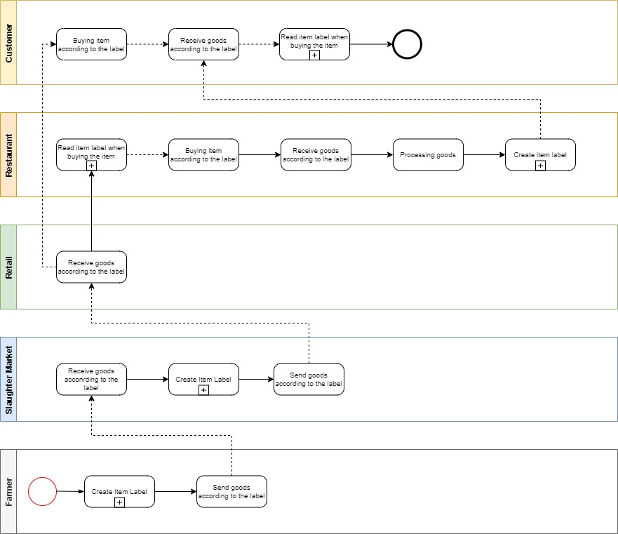

1. Supply Chain Business Process Using Blockchain (Slaughteer Market) Level 1

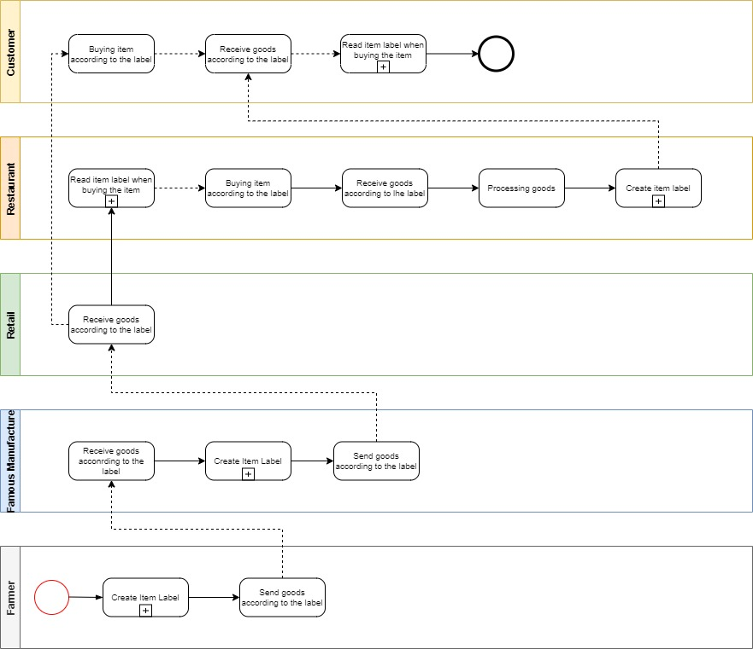

1. Supply Chain Business Process Using Blockchain (Famous Manufacturer) Level 1

It can be seen that all entities (except Retail) create labels of goods to be recorded in the blockchain. Before buying goods between entities, you can read the data on the blockchain through a QR Code affixed to the goods to see the entities that worked in the previous supply chain process.

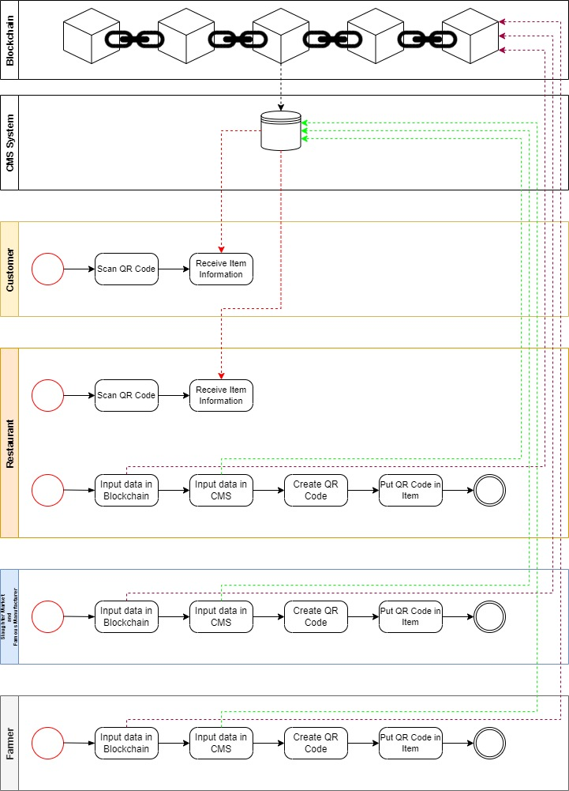

1. Supply Chain Business Process Using Blockchain (Slaughter Market/Famous Manufacturer) Level 2

The picture above is a detail of the activity of creating goods labels and reading labels when you want to buy products, in the process of creating goods labels between entities, it is necessary to enter data into the Blockchain by sending the tokens that have been created to the address used by the next entity so that the data transactions are recorded into the blockchain. Once the data is successfully recorded into the blockchain the next step is for the inter-entities to enter the data into the CMS according to their respective businesses. The browser site link resulting from the data entered into the CMS is converted into a QR Code by the inter-entity and then pasted into the product so that consumers can see the browser site containing Txn (Required) and others.

When consumers read the item label, simply scan the QR Code affixed by the supply chain entity to the item to see the supply chain process transactions on the blockchain. Of course, consumers can see the origin of the goods to be purchased (Depending on the agreement between the parties).

# Discussion

## Implementation

Some of the specifications, tools, and versions needed in this study are

* Python version 3.8 to run a CMS
* Wagtail Library with Django Framework
* GCP Instance of Asia-southeast zone1-a
* GCP Instances of e2-medium machine type
* Pragma solidity version 0.4.24
* ERC-20 Tokens

## Creating a Smart Contract

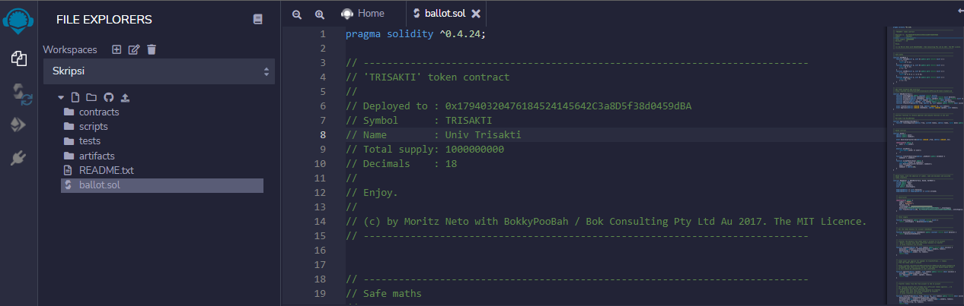

1. Smart Contract Modifications

Researchers created HAJW tokens with smart contracts using the solidity programming language version 0.4.24.

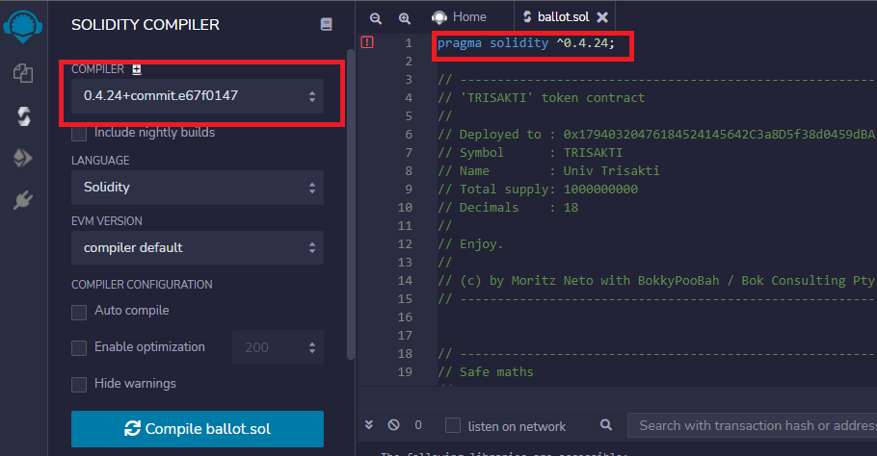

1. Compile Smart Contract

Researchers matched a pragma version of solidity with a compiler version of the Remix IDE.

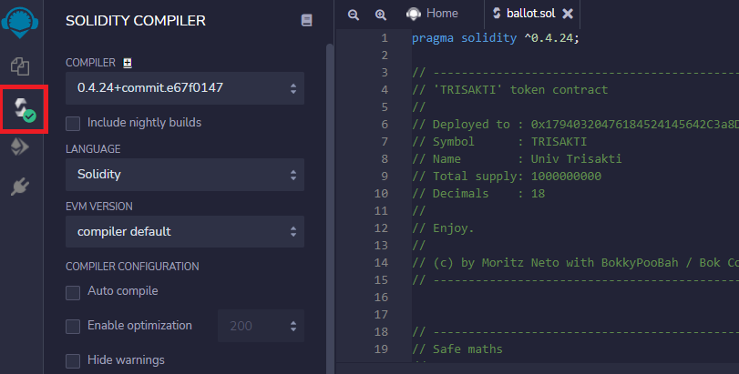

1. Successful Compile Smart Contract

In the picture above , it can be seen that the researcher successfully compiled the smart contract, if an error occurs or an error then the smart contract must be re-modified.

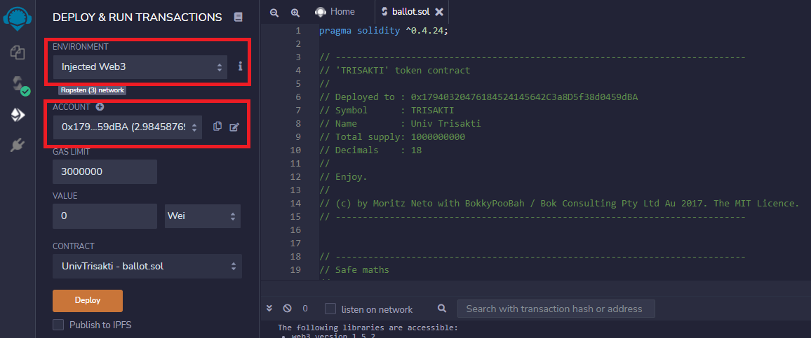

1. Deploy Smart Contracts With Injected Web 3

Researchers chose an Injected Web3 environment connected to an Ethereum account located on MetaMask to pay for deployment fees and be associated with the blockchain.

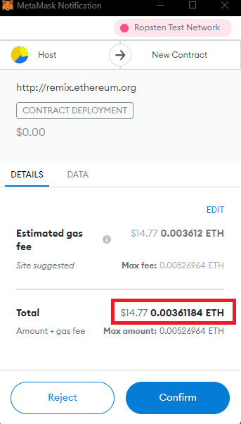

1. Confirm Deploy Smart Contract

In the picture above, it can be seen that the process of deploying a smart contract in token creation costs 0.00361184 ETH (Ether).

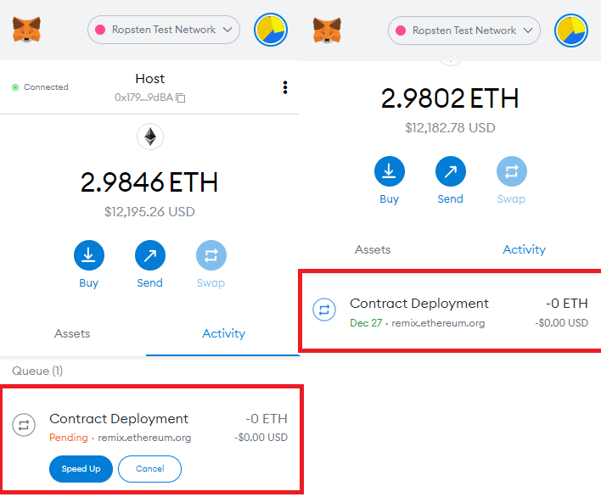

1. Deploy Smart Contract Activity

Next activity after payment of the smart contract deployment fee which can then continue the process of deploying into the blockchain. If the deployment has been successful then a MetaMask popup will appear.

## Input CMS

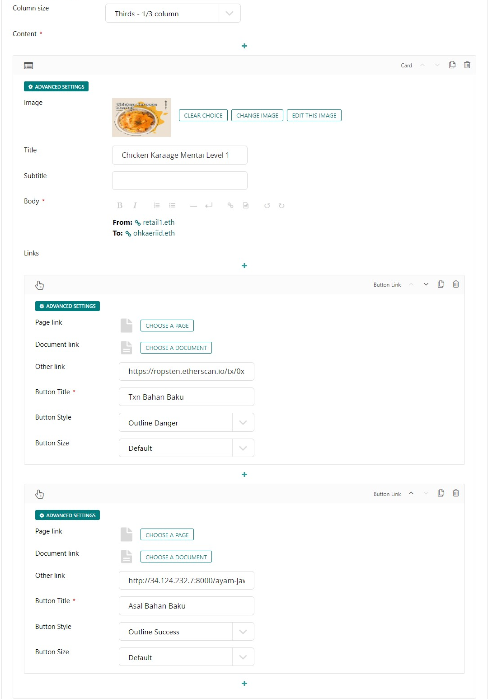

1. Column 1 Web Page

The image above is the first component encapsulated in a card element containing

* Photos or images of items purchased by customers
* The name of the item purchased by the customer
* Blockchain links of senders and receivers of supply chain actors
* Txn blockchain links
* Reference links from previous supply chain processes

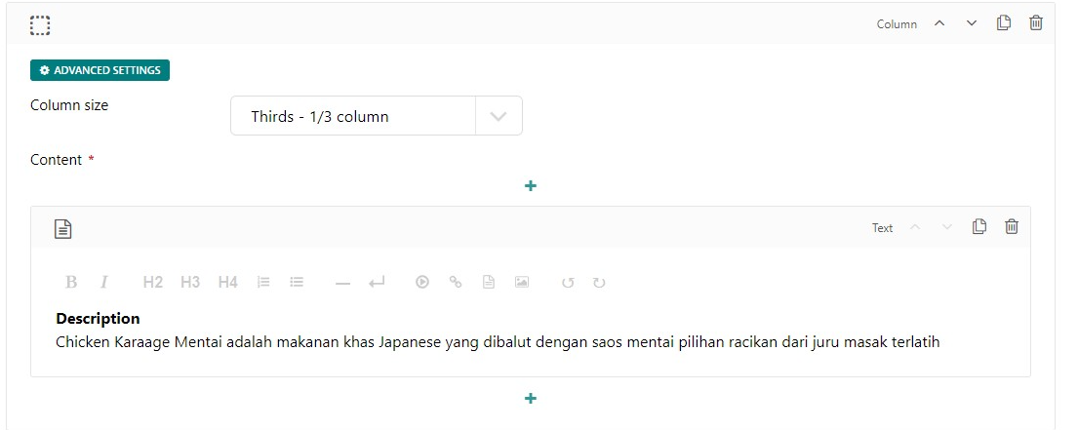

1. Column 2 web page

The picture above is a content that describes the goods.

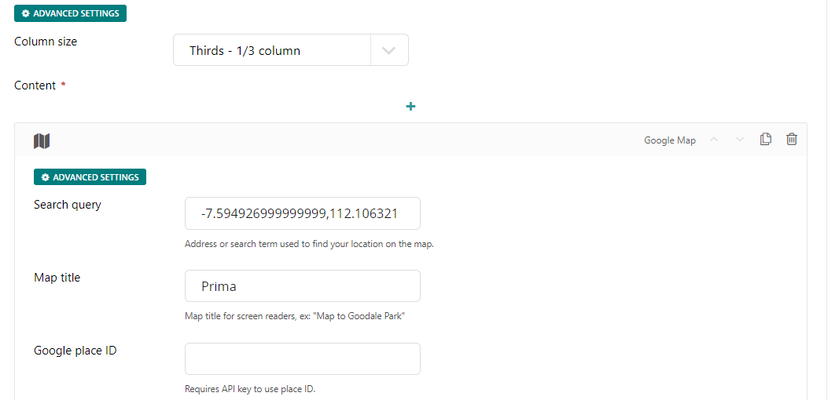

1. Column 3 Web Pages

On Fig. 20 is a component that displays a map of supply chain actors.

The content entered into the site page is the right of each entity, researchers create content as above because the content of the content is very transparent to be understood by customers.

## Logistics and Transport Process

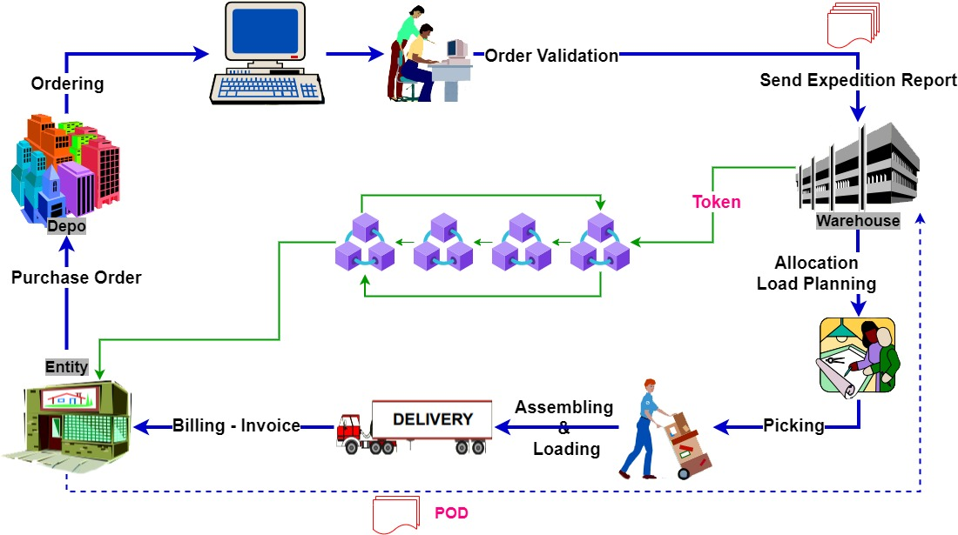

1. Supply Chain Process

The picture above is a supply chain process that begins with a purchase order activity (*Purchase Order*) to the depot, then the depot validates the order and sends an expedition report as well as an order to the warehouse. In the warehouse, the token transfer process and load planning allocation and expeditions are carried out to be assembled as well as validated orders before being delivered to retail. If the order is not appropriate when at retail, there will be a *Proof of Delivery* (POD) process where the retail and depot parties must fill out a form according to existing cases such as damaged/lost/exchanged goods, lack in products (missed in product) and other cases.

## Use of GCP (Google Cloud Platform) Services

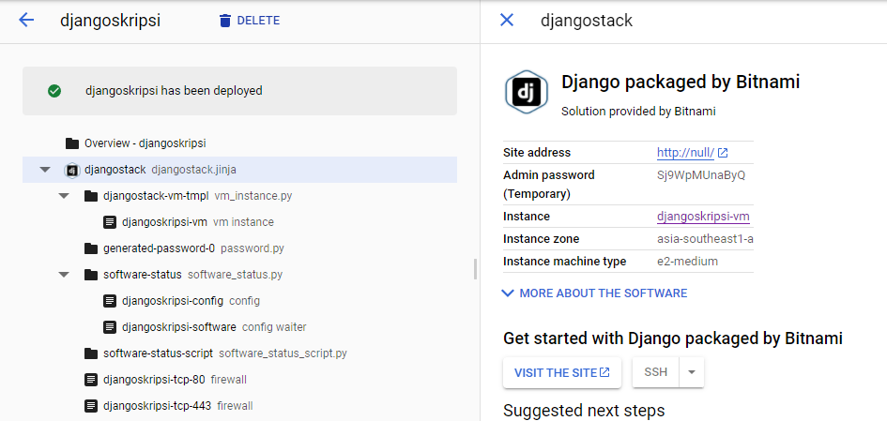

1. Djangostack Deployment Manager view

In this study, researchers used the Django Packaged by Bitnami deployment manager to deploy the CMS so that the CMS site was online.

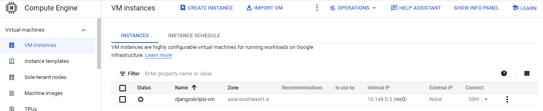

1. Server Instance View

In the Compute Engine service there is a view of the server instance with the following details

* Name is the name of the compute engine instance, djangoskripsi-vm.
* Zone is the location of the compute engine instance region zone located in asia-southeast1-a (Southeast asia region zone).
* Internal IP is the IP used to set the server instance.
* External IP is the most important part because external IP will be used to access the CMS.
* Connect is a place to connect to an SSH server.

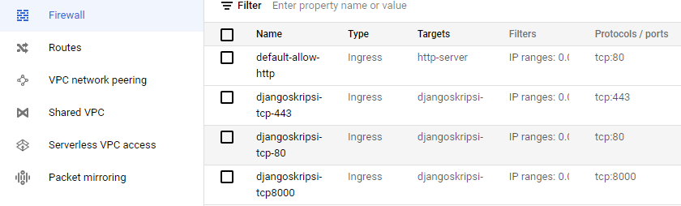

1. Firewall Settings view

In a VPC network, there are network settings so that you can access the external IP consisting of

* Name is the name of the firewall setting
* Type is an option of whether the network is linked to another GCP network service.
* Targets are which targets will be linked to the firewall settings that have been set.
* Filters contain the IP range that will be used to run the server.
* Protocols/ports contain number ports whose function is to be able to see the cms site display.

## Print QR Code

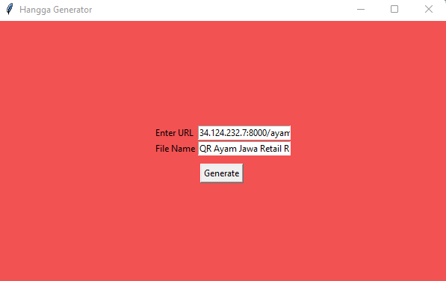

1. QR Code Generator System Display

The image above is a Sistem qr code maker which contains a link field and files name that must be filled in by users to get the QR Code as shown below.



1. QR Code Generator System Display

The QR Code above will display the link and move the customer to the predetermined link so that customers can see the process of the raw material supply chain until it is processed at the restaurant.

## Website Display

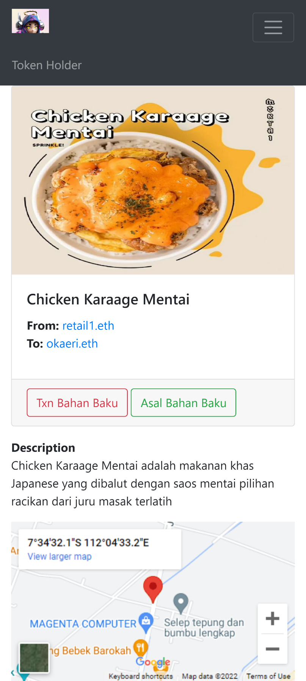

1. Website View After User Scans QR Code

After the user scans the QR Code, a web page like Fig 26. will appear which contains according to what has been entered in the CMS such as photos of purchased goods, information in the blockchain, descriptions of goods, maps of places of supply chain entities. Users can see the information in the blockchain when selecting the Raw Materials Txn button to ascertain whether it is true that the Ethereum addresses of supply chain actors work together.

# conclusion

## Conclusion

* Smart contracts make it easy between entities to get in touch with the blockchain.
* The design of this system successfully proves that supply chain transactions from upstream to downstream can be recorded on the blockchain
* Each entity will find it easier to see blockchain transaction data because transaction data is very transparent.
* In blockchain transactions, there is a gas fee or transfer fee, so it should be between entities to think of a special budget for the gas fee.
* Using Google Cloud Platform services makes it easy to host a CMS

## Suggestion

The blockchain system is arguably a very young system, until now the use of blockchain is only focused on cryptocurrency financial transactions between countries, therefore there is a need for more socialization efforts towards the use of this blockchain system so that it can be used for recording other transactions. It would be better in an effort to implement this supply chain system between entities from upstream to downstream to have a mutual agreement for transparency for end consumers.

##### References

1. C. Supaartagorn, "Web Application for Automatic Code Generator," pp. 114-117, 2017.
2. C. Supaartagorn, "Web Application for Automatic Code Generator Using a Structured Flowchart," pp. 114-117, 2017.
3. N. Sulaiman, S. Sakinah and S. Ahmad, "Logical Approach: Consistency Rules between Activity Diagrams and Class Diagrams," Advanced Science Engineering Information Technology, vol. 9, no. 2, pp. 552-559, 2019.
4. J.-G. Song, M. Sung-Jun and J. Ju-Wook, "A Scalable Implementation of Anonymous Voting over Ethereum Blockchain," Sensors, vol. 21, no. 3958, pp. 1-19, 2021.
5. A. K. Shrestha, J. Vassileva and R. Deters, "A Blockchain Platform for User Data Sharing Ensuring User Control and Incentives," vol. 3, pp. 1-22, 2020.
6. H. Shah, M. Shah, S. Tanwar and N. Kumar, "Blockchain for COVID-19: a comprehensive review," Personal and Ubiquitous Computing, pp. 1-28, 2021.
7. G. A. Motta, B. Tekinerdogan and N. Athanasiadis, "Blockchain Application in the Agri-Food Domain: The First Wave," vol. 3, pp. 1-13, 2020.
8. A. Maghfirah and Hara, "Blockchain in Food and Agriculture Supply Chain: Use-Case of Blockchain in Indonesia," International Journal of Food and Beverage Manufacturing and Business Models, vol. 4, no. 2, pp. 53-66, 2019.
9. H.-J. Kim and e. al, "Smart Decentralization of Personal Health Records with Physician Apps and Helper Agents on Blockchain: Platform Design and Implementation Study," JMIR Medical Informatics, vol. 9, no. 6, pp. 1- 14, 2021.
10. I. T. Javed, F. Alharbi, B. Bellaj, T. Margaria, N. Crespi and K. Naseer, "Health-ID: A Blockchain-Based Decentralized Identity," Healtcare, vol. 9, no. 712, pp. 1-21, 2021.
11. A. Hasselgren, Jens-Andreas, K. Kralevska, D. Gligoroski and A. Faxvaag, "Blockchain for Increased Trust in Virtual Health Care:," Journal Medical Internet Research, vol. 23, no. 7, pp. 1-15, 2021.
12. G. Gursoy, C. M.Brannon and M. Gerstein, "Using Ethereum blockchain to store and query pharmacogenomics data via smart contracts," BMC Medical Genomics, vol. 13, no. 74, pp. 1-11, 2020.
13. C. D. Clack, "A Blockchain Grand Challenge: Smart Financial Derivatives," vol. 1, no. 1, pp. 1-3, 2018.
14. M. S. Al-Rakhami and M. Al-Mashari, "A Blockchain-Based Trust Model for the Internet of Things Supply Chain Management," sensors, vol. 21, no. 1759, pp. 1-15, 2021.
15. M. S. Ali, M. Vecchio, G. D. Putra and S. S. Kanhere, "A Decentralized Peer-to-Peer Remote Health Monitoring System," Sensors, vol. 20, no. 1656, pp. 1-18, 2020.
16. K. e. al, "Smart Decentralization of Personal Health Records with Physician Apps and Helper Agents on Blockchain: Platform Design and Implementation Study," JMIR MEDICAL INFORMATICS, vol. 9, no. 6, pp. 1-14, 2021.
17. A. Akhtar, A. Afzal, B. Shafiq, S. Shamail, J. Vaidya and O. Rana, "Blockchain Based Auditable Access Control for," International Conference on Distributed Computing Systems (ICDCS), vol. 40, pp. 12-22, 2020.